|  |  |
| --- | --- |
| Faculty of Computer & Information Sciences  Ain Shams University  Subject: Math 4  Year: (2nd ) undergraduate  Academic year: 2nd term 2019-2020 |  |

**Research Topic (3)**

**Title: Constant-Harvest Model**

**Introduction about Ordinary differential equation (**Ref. 1**)**

An ordinary differential equation (ODE) is an equation that involves some ordinary derivatives (as opposed to partial derivatives) of a function. Often, our goal is to *solve* an ODE, i.e., determine what function or functions satisfy the equation.

If you know what the derivative of a function is, how can you find the function itself? You need to find the antiderivative, i.e., you need to integrate. For example, if you are given

dx/dt(t)=cost (t)

then what is the function x(t)? Since the antiderivative of cos t is sin t, then x(t) must be sin t. Except we forgot one important point: there is always an arbitrary constant that we cannot determine if we only know the derivative. Therefore, all we can detetermine from the above equation is that

x(t) = sin t + C

for some arbitrary constant C. You can verify that indeed x(t) satisfies the equation dx/dt=cos t.

In general, solving an ODE is more complicated than simple integration. Even so, the basic principle is always integration, as we need to go from derivative to function. Usually, the difficult part is determining what integration we need to do.

**List essential equations to solve initial value problem using Laplace transform** (Ref. 2)

|  |  |
| --- | --- |
| **f(t)={F(s)}** | **F(s)=L{f(t)}** |
| * 1 |  |
|  |  |
| * ,n=1,2,3,… |  |
|  |  |
|  |  |
| * , n=1,2,3,… |  |
| * sin(at) |  |
| * cos(at) |  |
| * tsin(at) |  |
| * tcos(at) |  |
| * sin(at)−atcos(at) |  |
| * sin(at)+atcos(at) |  |
| * cos(at)−atsin(at) |  |
| * cos(at)+atsin(at) |  |
| * sin(at+b) |  |
| * cos(at+b) |  |
| * sinh(at) |  |
| * cosh(at) |  |
| * sin(bt) |  |
| * cos(bt) |  |
| * sinh(bt) |  |
| * cosh(bt) |  |
|  |  |
| * (ct) |  |
| * uc(t)=u(t−c) |  |
| * δ(t−c) |  |
| * uc(t) f(t−c) |  |
| * uc(t) g(t) | L { g(t+c) } |
|  | F(s−c) |
|  |  |
|  |  |
|  |  |
|  | F(s) G(s) |
| * (t+T) = (t) |  |
|  | S F(s) − (0) |
| * ′′(t) | (0)- |
| * (t) | (0)-(0)-(0) |

**Discuss the constant –Harvest Model an explain the meaning of each term in the equation.**

P(t) :the population of fishery

P0 : the initial population

h :harvest rate (decreases the population)

K : growth rate

dp/dt : rate of change of population with time

------------------------------------------------------------------------------------------------

**Solve the Constant-Harvest Model, Solve the DE subject to P(0) =P0**

ln (kP - h) = k t + c1

k P – h =

k P = c + h

Then we have

P = n + (1)

After that, to find the value of constant n, we have to apply the point of condition (P , t) = (P0 , 0) into equation (1), then we have

P0 = n

Then we have

C = P0 -

After that, substitute with the value of constant n into equation (1), then we have

P = (P0 - ) + (2)

is the population of the fishery at time t .

**Describe the behavior of the population P(t) for increasing time in the three cases:**

1. **P (0) > h/k :**

We find that the R.H.S is increasing, then the population of the fishery keeps on increasing.

1. **P (0) = h/k :**

We find that the R.H.S equals h/k, then the population becomes constant, P = P0

1. **P (0) < h/k :**

We find that the R.H.S is decreasing, then the population of the fishery keeps on decreasing.

**Use results from part B to determine whether the fish population will ever go to extinct in finite time, that is, whether there exists a time T>0 such that P(T)=0. If the population goes to extinct, then find T.**

the time to extinct:

p=(p0 - ) +

p=0

- = (p0-)

= - (p0 - )

=

let to affect ln() of two sides

ln()=ln( )

kt=ln ( )

t(extinct)=() ln ( )

at case B

p0=

-> t is not exist

-> the population can't extinct

**Graph P(t) versus time t. Your graph must show the three cases mentioned in question number 5. (**Ref. 3**)**

A) P (0) > h/k

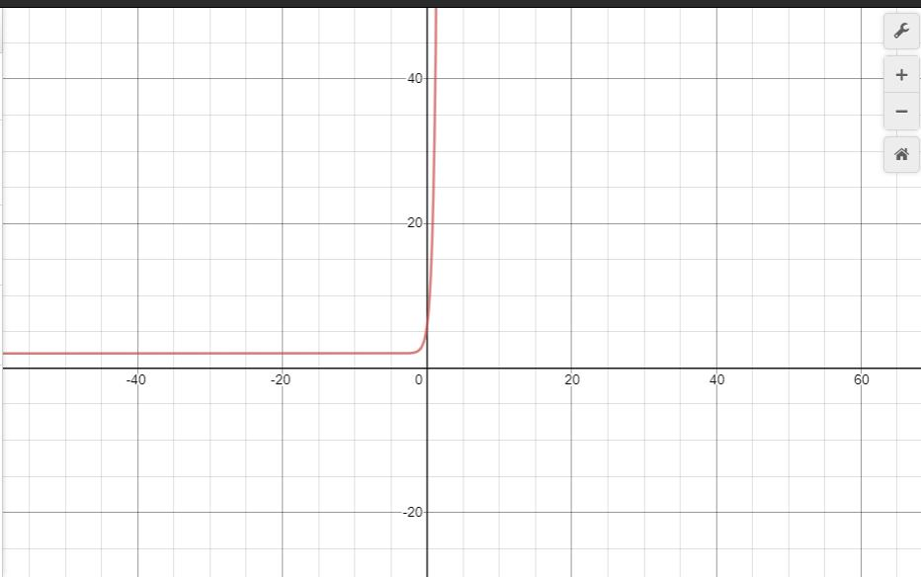

B) P(0) = h/k

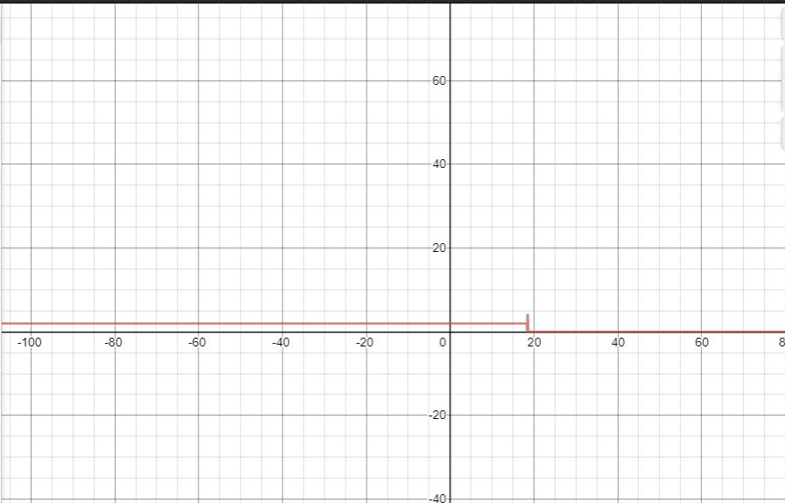

C) P (0) < h/k

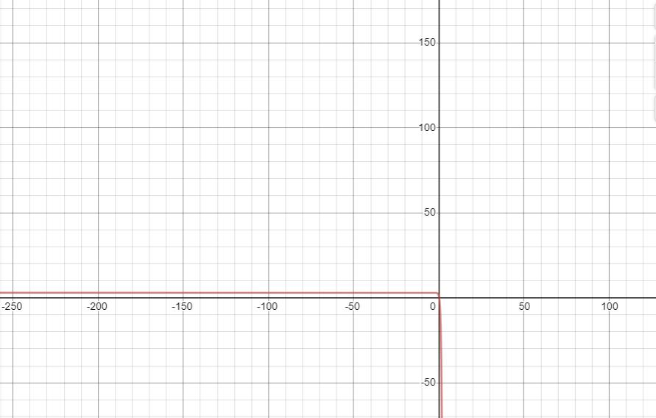

**Reference:**

[1] Math Insight (Website) : [Link](https://mathinsight.org/ordinary_differential_equation_introduction)

[2] Pauls Notes (Website) : [Link](https://tutorial.math.lamar.edu/Classes/DE/Laplace_Table.aspx)

[3] Desmos (Website) : [Link](https://www.desmos.com/calculator/dffgfp3ses)

[4] ……………………………………………………………………………

[5] ……………………………………………………………………………

[at least 5 references]